Experiment No.: 1
1. Experiment Title:
Demonstrate inline, internal, and external JavaScript; use console methods; create a webpage showing user info and a welcome message.
2. Software/Tools Required:
Visual Studio Code (or any text editor), Web Browser (Google Chrome/Mozilla Firefox), JavaScript
3. Experiment Program Code:
greet.js
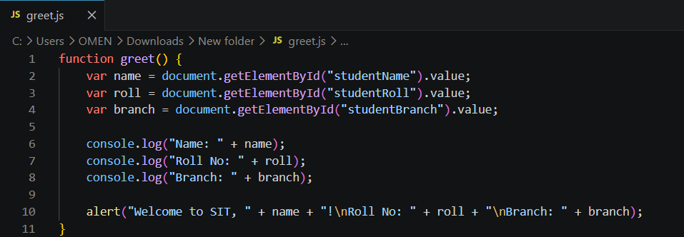
Index.html
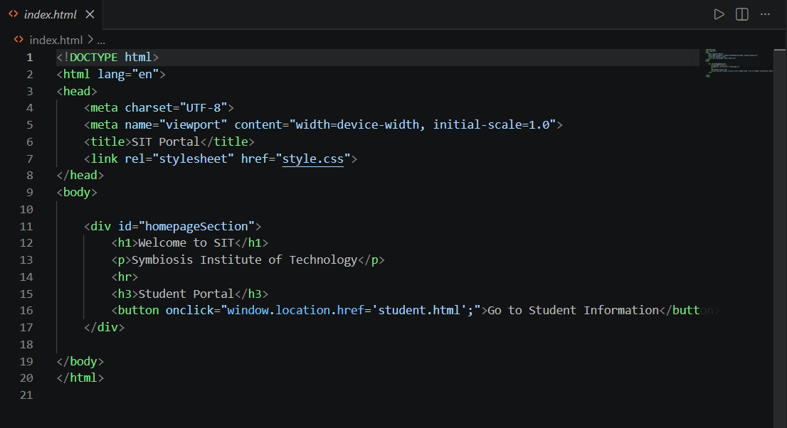
student.html
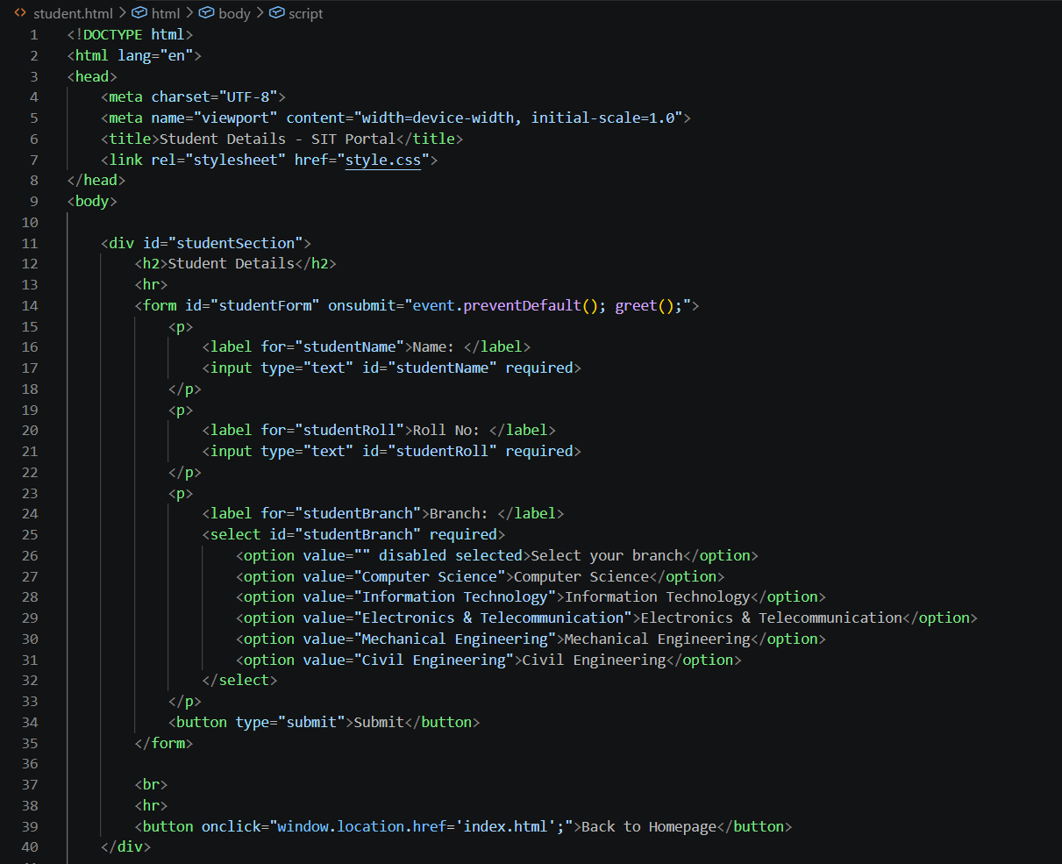
4. Output:
